Rudenka Mikita Pavlovich Laravel Blog

**Description:**

You are tasked with creating a simple blog application using Laravel version 9 or higher. This application should allow users to view a list of blog posts, read individual blog posts, and create new blog posts. The assignment is divided into several tasks, each building upon the previous one.

**Task 1: Setup and Configuration (10 points)**

* Create a new Laravel project with the latest version.

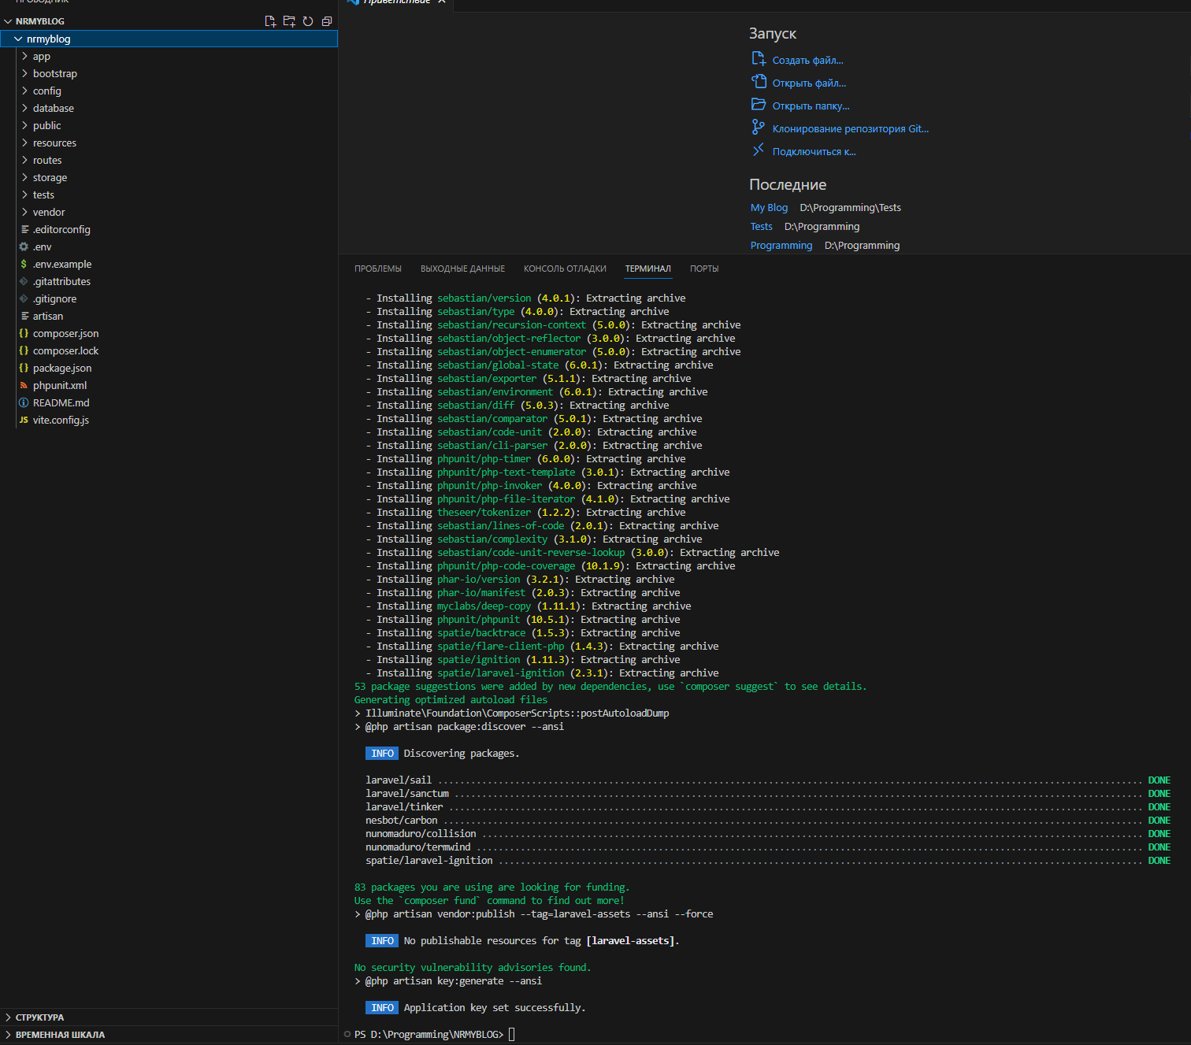

* Configure your database connection in the .env file.

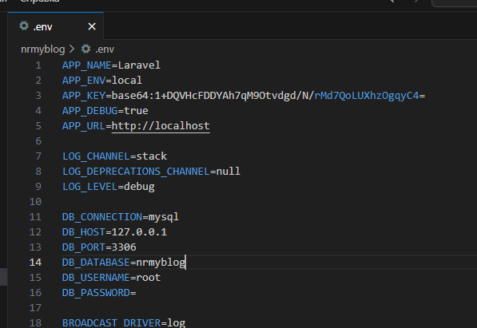



* Create a migration for a posts table with fields for title, content, and published_at.

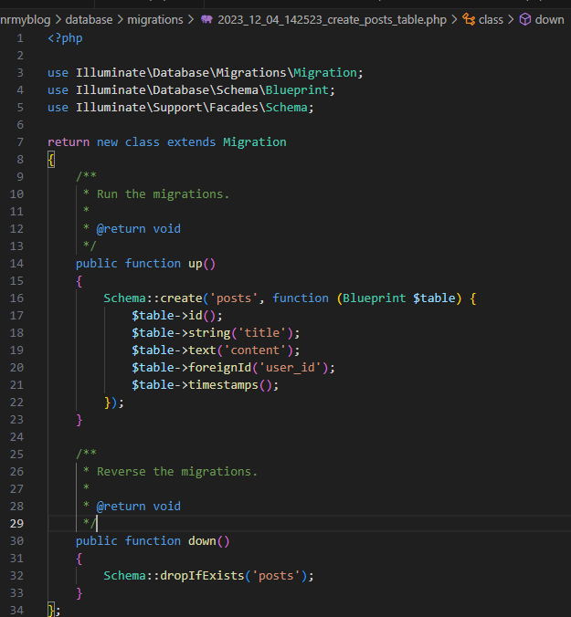

* Run the migration to create the posts table.



**Task 2: Create Models and Relationships (15 points)**

* Create a Post model.

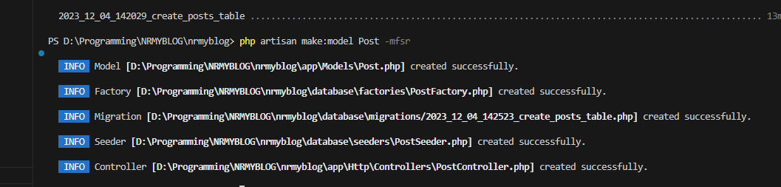

* Define the relationship between Post and any other necessary models.

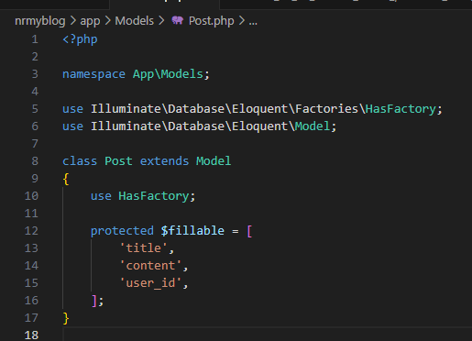

* Create factory and seeders for generating sample data.

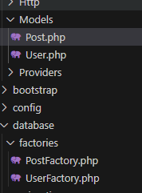

* Seed the posts table with at least 10 sample blog posts.

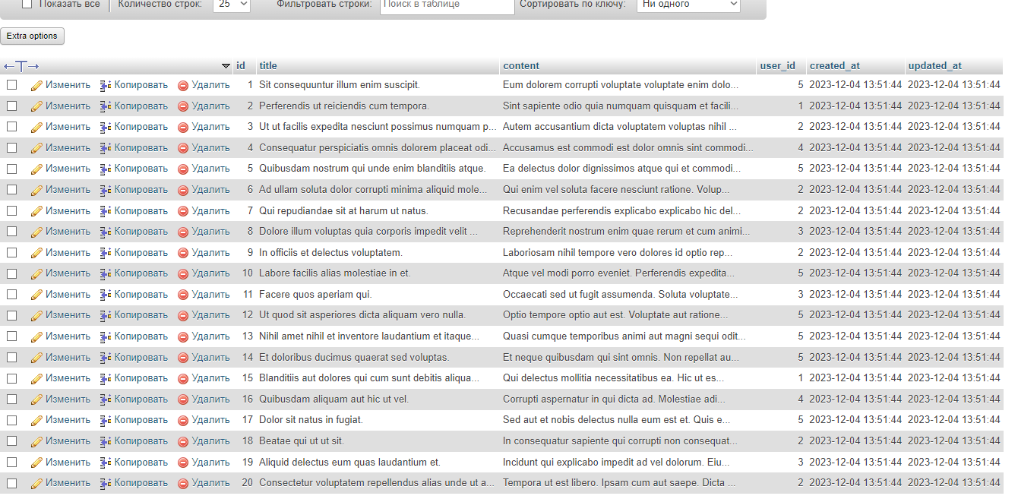

**Task 3: Create Routes and Controllers (15 points)**

* Create routes for viewing a list of blog posts and individual blog posts.

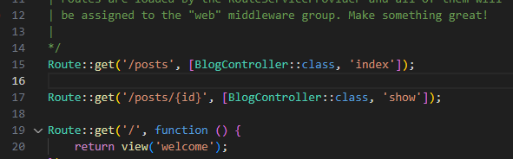

* Create controllers for handling these routes.

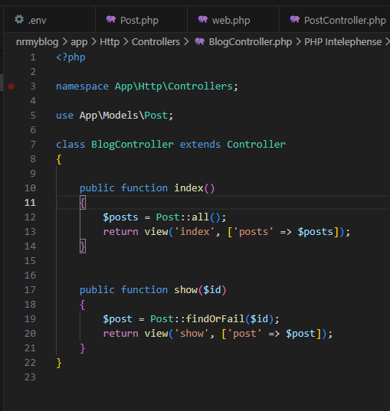

* Implement the necessary methods in controllers to retrieve and display the data

**Task 4: Create Views (20 points)**

* Create Blade views for displaying a list of blog posts and individual blog posts.

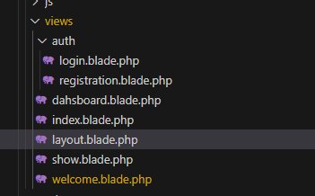

* Use a master layout file for consistent styling.

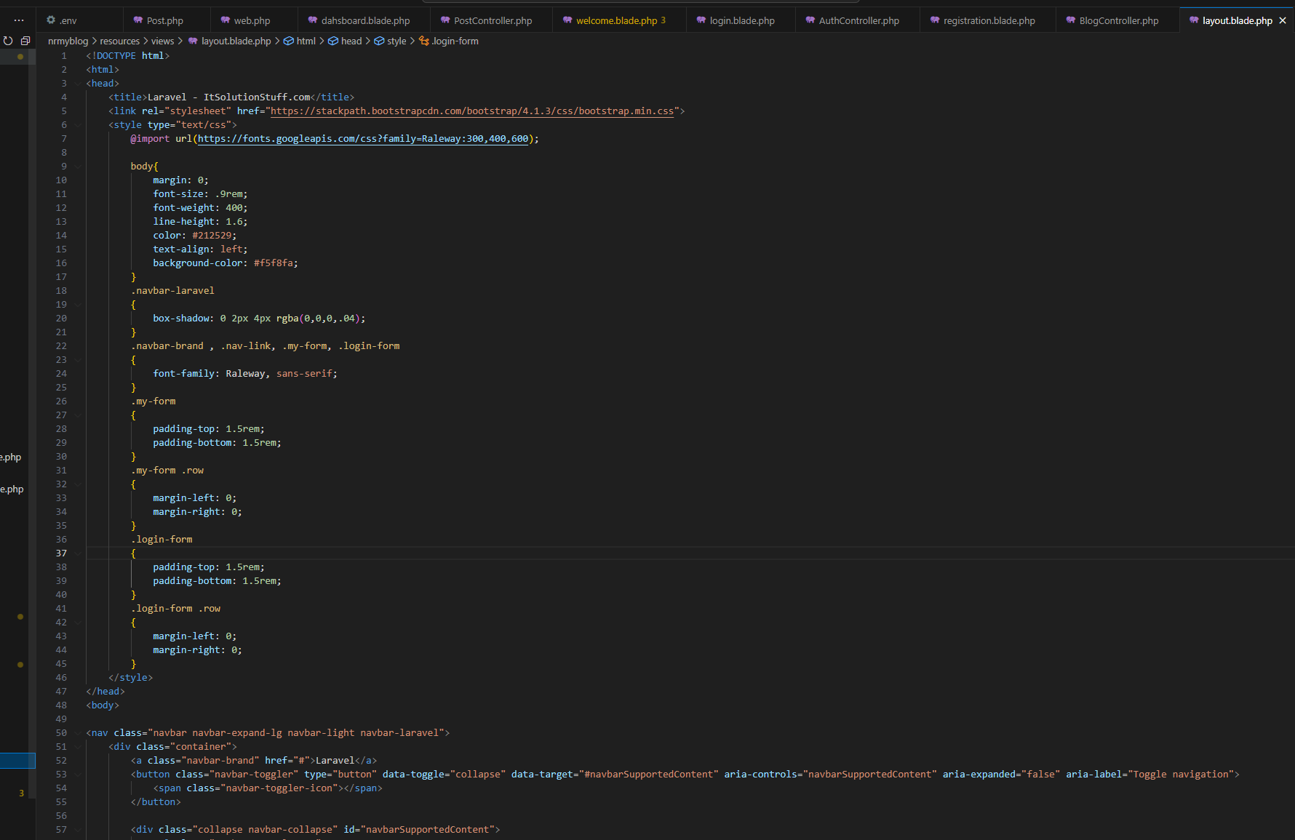

* Include navigation to navigate between the list of posts and individual posts

**Task 5: Create a Form for Adding Blog Posts (20 points)**

* Create a form for adding new blog posts.
* Implement server-side validation to ensure the title and content are not empty.
* Store the new blog post in the database.
* Display a success message upon successful submission

**Task 6: Implement Editing and Deleting (20 points)**

* Allow users to edit and delete existing blog posts.
* Create routes, controllers, and views for editing and deleting posts.
* Implement server-side validation for editing and deleting posts.

**Task 7: Bonus Features (10 points)**

* Implement a feature to allow users to add comments to blog posts.
* Add pagination to the list of blog posts.
* Implement user authentication and authorization, so only authenticated users can create, edit, and delete posts.

------------------------------------------------------------------------------------------------  
